Eventi
An Event Sharing Website

Submitted to:

Prof. Ma. Rowena C. Solamo
Faculty Member
Department of Computer Science
College of Engineering
University of the Philippines, Diliman

Submitted by:
Dimaano, Aaron Diego I.
Lopez, Matthew S.
Torres, Jacob Angelo V.

In partial fulfillment of Academic Requirements
for the course
CS 191 Software Engineering I
of the
1st Semester, AY 2014-2015

Unique Reference:
The documents are stored in this repository: https://github.com/Tom-2013-06417/CS191-192_Event_Sharing
Link to this document: https://github.com/Tom-2013-06417/CS191-192_Event_Sharing/blob/master/01-Project%20Documents/1.1%20Project%20Description(version%201.1).pdf

Document Purpose:
The purpose of this document is to elaborate on the conception, processes, and features of the site as a website. Through the included context diagram, this document also aims to show how the users are to interact with the software.

Target Audience:
To our project client and adviser, our fellow 191 classmates, and our future selves when they need to refer back to this document.

Revision Control:

Revision Date | Person Responsible | Version Number | Modification
08/26/2015 | Diego Dimaano  Matthew Lopez  Jacob Torres | 1.0 | Initial Document
08/26/2015 | Diego Dimaano  Matthew Lopez  Jacob Torres | 1.1 | Revised according to the specifications  discussed in class

Project Title: Eventi

Description:
Eventi is a website that aims to centralize all general events within the university and therefore providing a platform for those who seek publicity for their event as well as for those who want a single go-to site containing for everything they need to know about the events in UP.

Context Diagram:

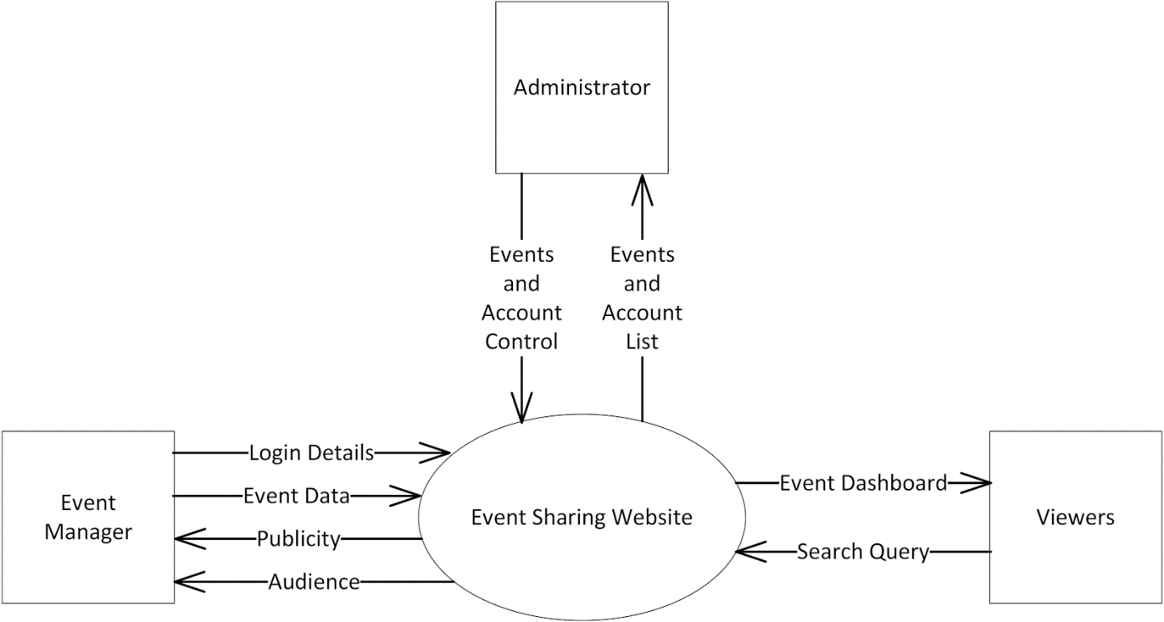

Entities:
- Viewer
  - is a person that entered the site for the purpose of looking up event details
  - interacts with the dashboard when they use the site
  - has a login option that provides additional functionalities such as saving to a calendar, subscribing to certain users, and following uploads under certain tags
  - reports to the administrator whenever they encounter wrong, malicious, or illegal content on the site
- Event Manager
  - is a person (usually an organization representative, an event host, a typical student, etc.) who uses the site to upload or manage the events to be publicized
  - interacts with the interface by adding events and posting updates to the site’s database
  - provides login credentials to upload and edit event details
- Administrator
  - manages the safety and credibility of the site and its events
  - warns, suspends, or terminates accounts that post malicious or illegal content on the site

Major Input:

Events
- Event details are to be inputted by registered event managers to be included to the site’s public dashboard
- Required Event Details:
  - Event Name
  - Event Description
  - Tags
  - Venue
  - Date/Duration
  - Publicity Material Image/s
  - Contact Details
  - Event Organizers
  - Event Price (if any)
- Additional Event Details:
  - Event Capacity
  - Attire
  - Things to Bring
  - Miscellaneous Info
  - Target Audience
  - RSVP Form Link
  - Link to main site/page

Major Outputs:

Event Dashboard
- Displays the events of the user account currently in the site’s database
  - Prioritizes events that are immediate, trending, or promoted
  - Suggests events based on recent search information
- Provides an interface to view all recently posted events
  - Contains functionalities for searching events using keywords and tags
  - Can be customized by logged in users through tags and subscription to other users and events

User Calendar and Unified Timeline
- Displays the events the user subscribed to in calendar or timeline form
- Reminds the user of upcoming events

Major Functionalities:
- Event Management Features
  - upload new events
  - edit posted events while notifying subscribers
- Event Dashboard
  - display events sorted either by popularity, relevance, tags, or time of upload
  - can be customized by logged in users to manage the events they see by subscribing to the users and event tags they want to see on their personal dashboards
- Account Information Management
  - edit account information
  - view personal calendar, timeline, and subscribed events
- Events Promotion
  - pay the site money to make sure your event gets noticed more often

